EXAM 2

Octavio Villalaz

1)

a)

***SELECT COUNT(*) FROM scale1.customer;***

***result = 150000***

***SELECT COUNT(*) FROM scale1.lineitem;***

***result = 6001215***

***SELECT COUNT(*) FROM scale1.orders;***

***result = 1500000***

***SELECT COUNT(*) FROM scale1.part;***

***result = 200000***

***SELECT COUNT(*) FROM scale1.partsupp;***

***result = 800000***

***SELECT COUNT(*) FROM scale1.region;***

***result = 5***

***SELECT COUNT(*) FROM scale1.supplier;***

***result = 10000***

***SELECT COUNT(*) FROM scale1.nation;***

***result = 25***

b)

Duration:

***12007464.963ms (3:20:07.465)***

c)

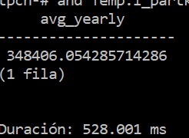Duration:

***528.001ms***

Unnested Query:

***CREATE TABLE scale1.Temp(l_partkey,avg) as***

***SELECT l_partkey, 0.2 * avg(l_quantity)***

***FROM scale1.lineitem***

***GROUP BY l_partkey;***

***SELECT***

***sum(l_extendedprice) / 7.0 as avg_yearly***

***FROM***

***scale1.lineitem as l,***

***scale1.part,***

***scale1.Temp***

***WHERE***

***p_partkey = l.l_partkey***

***and p_brand = 'Brand#23'***

***and p_container = 'MED BOX'***

***and l_quantity < Temp.avg***

***and Temp.l_partkey = p_partkey;***

d)

Normal Q17 Query

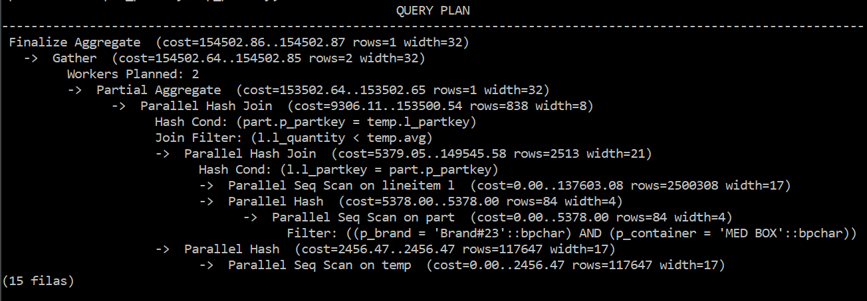

Unnested Q17 Query

The overall estimated cost of the unnested Q17 query plan (154502.87) is lower compared to the normal Q17 query plan (2070858.42). This cost reductions made the unnested Q17 query take less than a second to run compared to the 3 hours and 20 min for the normal Q17 query. Some key differences that make the unnested Q17 query plan faster are:

* Parallel Hash Join which distribute the join operation across multiple workers.
* Partial Aggregate step before finalizing the aggregate result. This is more efficient than computing the aggregate over the entire dataset in one go.

2)

a)

***CREATE MATERIALIZED VIEW scale1.mv_q5 AS***

***select***

***l_suppkey,***

***c_nationkey,***

***sum(l_extendedprice * (1 - l_discount)) as revenue***

***from***

***scale1.orders,***

***scale1.customer,***

***scale1.lineitem***

***where***

***o_custkey = c_custkey***

***and l_orderkey = o_orderkey***

***and o_orderdate >= date '1994-01-01'***

***and o_orderdate < date '1994-01-01' + interval '1' year***

***group by***

***l_suppkey, c_nationkey;***

b)

Original TPCH Q5 Benchmark query

***time = 509.600ms***

c)

***select***

***n_name,***

***SUM(revenue) as revenue***

***from***

***scale1.mv_q5,***

***scale1.supplier,***

***scale1.nation,***

***scale1.region***

***where***

***l_suppkey = s_suppkey***

***and c_nationkey = s_nationkey***

***and s_nationkey = n_nationkey***

***and n_regionkey = r_regionkey***

***and r_name = 'ASIA'***

***group by***

***n_name***

***order by***

***revenue desc;***

d) Query using materialized view

***Time = 53.180 ms***

3)

Insertion Tables

***CREATE TABLE ORDER_INSERTIONS (***

***o_orderkey INT PRIMARY KEY,***

***c_custkey INT***

***);***

***CREATE TABLE CUSTOMER_INSERTIONS (***

***c_custkey INT PRIMARY KEY***

***);***

*Trigger for ORDER table*

***CREATE TRIGGER order_insert_trigger***

***AFTER INSERT ON ORDER***

***FOR EACH ROW***

***BEGIN***

***INSERT INTO ORDER_INSERTIONS (o_orderkey, c_custkey)***

***VALUES (NEW.o_orderkey, NEW.c_custkey);***

***END;***

*Trigger for CUSTOMER table*

***CREATE TRIGGER customer_insert_trigger***

***AFTER INSERT ON CUSTOMER***

***FOR EACH ROW***

***BEGIN***

***INSERT INTO CUSTOMER_INSERTIONS (c_custkey)***

***VALUES (NEW.c_custkey);***

***END;***

*Updater(Count Alogrithm)*

***UPDATE OrdCost***

***SET sum(o_totalprice) = (***

***SELECT SUM(o_totalprice)***

***FROM ORDER_INSERTIONS oi***

***JOIN CUSTOMER_INSERTIONS ci ON oi.c_custkey = ci.c_custkey***

***JOIN ORDER o ON oi.o_orderkey = o.o_orderkey***

***JOIN CUSTOMER c ON oi.c_custkey = c.c_custkey***

***WHERE o.o_shippriority = 0 AND c.c_acctbal > 0***

***);***

4)

See SQL Script “sakila-schema-modified-to-postgres”

5)

a)

L_ORDERKEY: 4 bytes (integer)

L_PARTKEY: 4 bytes (integer)

L_SUPPKEY: 4 bytes (integer)

L_LINENUMBER: 4 bytes (integer)

L_QUANTITY: 8 bytes (decimal)

L_EXTENDEDPRICE: 8 bytes (decimal)

L_DISCOUNT: 8 bytes (decimal)

L_TAX: 8 bytes (decimal)

L_RETURNFLAG: 1 byte (char)

L_LINESTATUS: 1 byte (char)

L_SHIPDATE: 4 bytes (date)

L_COMMITDATE: 4 bytes (date)

L_RECEIPTDATE: 4 bytes (date)

L_SHIPINSTRUCT: 25 bytes (char)

L_SHIPMODE: 10 bytes (char)

L_COMMENT: 44 bytes (varchar)

Adding these up gives us a total row size of 124 bytes.

So, the size of storing the Lineitem table in a traditional (row-based) file would be approximately:

6001215 * 124 bytes = 744,148,860 bytes = ***744.15 megabytes***.

b)

Used columns:

L_RETURNFLAG: 1 byte (char) / 5 = 0.2 bytes

L_LINESTATUS: 1 byte (char) / 5 = 0.2 bytes

L_QUANTITY: 8 bytes / 5 = 1.6 bytes

L_EXTENDEDPRICE: 8 bytes / 5 = 1.6 bytes

L_DISCOUNT: 8 bytes / 5 = 1.6 bytes

L_TAX: 8 bytes / 5 = 1.6 bytes

L_SHIPDATE: 4 bytes (date) / 5 = 0.8 bytes

Total = 6001215 * 7.6 bytes = 45,609,234 bytes = ***45.61 megabytes***.

c)

***Cost = 231,176.37***

d)

Everything will be the same except the last operation ”Parallel Seq Scan on lineitem” that is replaced with:

***Late Materialized Columnar Scan on lineitem***

***Filter: (l_shipdate <= '1998-09-02 00:00:00'::timestamp without time zone)***

e)

M = 124 bytes

N = 7.6 bytes

Cost = (124log(124) ) + (7.6log(7.6)) + 124 + 7.6 = ***744.288***

f)

Looking at the cost of the columnar database we can see that it has a much lower cost meaning that doing a merge-sort join will be faster.